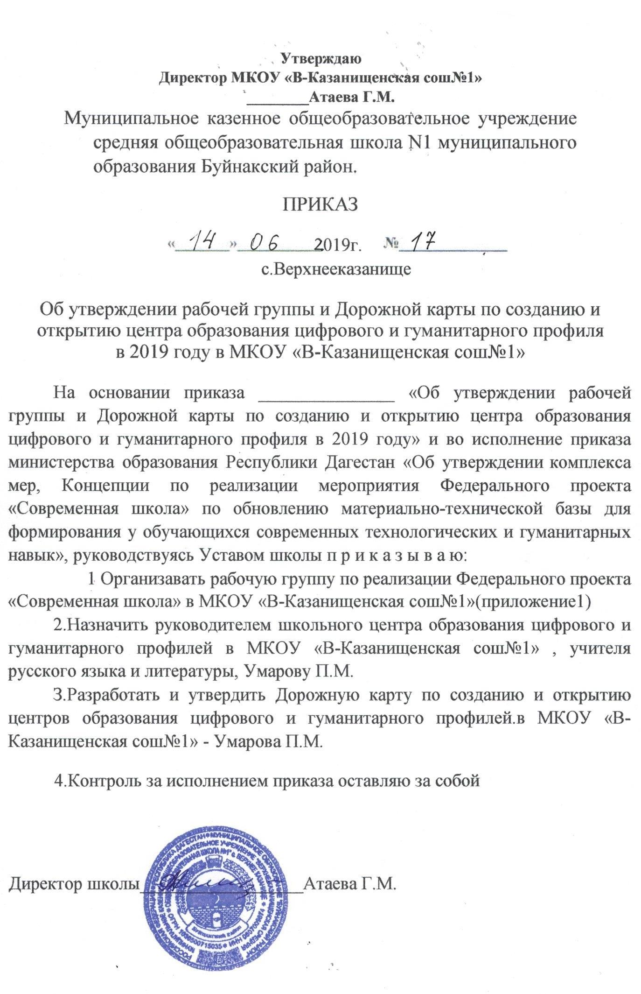

|  |  |
| --- | --- |
| C:\Users\Заира\AppData\Local\Microsoft\Windows\Temporary Internet Files\Content.Word\7 002.jpg |  |

